OBITUARY

DR TIMOTHY WILLIAM PROUDMAN AM MBBS, MS, FRACS
PLASTIC & RECONSTRUCTIVE SURGEON
8 JANUARY 1962 – 22 FEBRUARY 2024

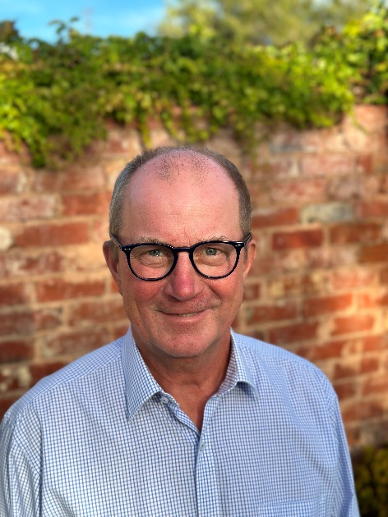 | Tim was born in Adelaide in early 1962 to Esmé and the late Dr Bill Proudman AO, who was a renowned general surgeon and educator. Tim had a happy childhood and sports and outdoor activities were a priority. He particularly excelled in AFL, but he was a terrific all-round athlete.  Tim showed grit and a stoic nature from an early age. At the age of 7 at the family’s beach house in semi-rural Adelaide, Tim seriously cut his foot on sharp rocks at a construction site. As the dirt roads to a hospital involved several hours of travel, Tim’s father Bill sutured Tim’s foot on the kitchen table without anaesthetic. There was no crying or yelling from Tim, as attested by his 2 brothers.  I was fortunate to get to know and become a friend of Tim’s at school at the age of 10. Tim was very popular due to his athleticism, but also due to his ability to sing, tell stories, act, have fun and for his overwhelmingly decent nature.
After finishing high school in Adelaide, Tim attended Sedbergh School, a boarding school since 1525, located between the Yorkshire Dales and the Lakes District. Tim’s mother Esmé was English, and believed with some good reason that some English flair would rub off on Tim and his brothers, each of whom attended Sedbergh after finishing high school (as did Tim’s own children and a nephew). Here Tim flourished. Amongst other pastimes, Tim excelled at running miles over the freezing moors in old-fashioned sandshoes. He made several lifelong friends at the school, such was his nature.

Upon returning to Australia, Tim completed Medicine at the University of Adelaide, then commenced training in Plastic and Reconstructive Surgery in Adelaide, completing his training in Brisbane and receiving his FRACS in 1996. Following this he undertook a Fellowship at St James University Hospital, Leeds, United Kingdom.

Tim’s achievements since commencing practice in Adelaide are outstanding – the amazing thing was he made all of what follows seem like it was all in a day’s work. Hundreds and hundreds of hours were given to voluntary work for the community, the profession and the international community.

Cherry-picking from his CV, Tim was Head of Unit at The Women’s and Children’s Hospital (Adelaide) 2009 to 2013. Here he set up a multidisciplinary Paediatric Brachial Plexus service, which continues to this day under surgeons mentored by Tim. He was a long-standing Head of Unit at the Queen Elizabeth Hospital, Adelaide. Tim was the President of the SA Branch of the Australian Society of Plastic Surgeons (ASPS) and SA State Chair of the Board of Plastic and Reconstructive Surgery, RACS.

He was the National Chair of the Training Committee for Plastic Surgery 2007-2009, and Chairman of The Board of Plastic and Reconstructive Surgery, as well as an Examiner, ultimately Senior Examiner, of the Court of Examiners in Plastic and Reconstructive Surgery.

Tim’s humanitarian work involved volunteering for Interplast missions to Bhutan where he became the volunteer coordinator. Surgery in Bhutan consisted of burns, hand surgery and dealing with injuries sustained by black bear attacks. Tim completed eight missions and raised much-needed funds via fundraising events hosted at his home by Tim and his wife, Susanna. These events helped fund teams to go to Interplast locations including Bhutan but Tim also set up and funded a training pathway for Bhutan’s first Plastic and Reconstructive Surgeon, through mentoring in Bhutan, online lectures and mentoring in 2020-2022, and ultimately the training in Adelaide in 2023 of Dr Sonam Jamtsho.

Tim also found time to teach wound management through the Australasian Foundation for Plastic Surgery in Maningrida, Nhulunbuy and Groote Eylandt. Tim took great pleasure in the interesting generational fact that he assisted his father, Bill; that Bill assisted him, and that Tim’s son, Will assisted Tim on a mission to Bhutan.

In 2022, Tim was awarded the Sir Henry Newland Award for outstanding service to the community, to medicine and to the Royal Australasian College of Surgeons. His father Bill was similarly honoured with this award in 2015, and they are the only father son combination to have achieved this honour.

Yet, despite these outstanding professional accomplishments, it was the human Tim who was loved and respected. The Tim who was incredibly unassuming and humble, who could always make one laugh, and in whose company, time was always well spent.

Tim was an avid fisherman at Encounter Bay and his beloved sanctuary, Thistle Island, and raising a toast with Tim to the day’s catch of whiting or crayfish with a glass of wine was one of the great pleasures of life.

Tim’s diagnosis of a high-grade glioblastoma came unexpectedly after a scan prompted by Tim not being able to recall some details of a well -known story he was telling one weekend in November 2021.

Tim and his wife Susanna (Professor and Head of the Rheumatology Unit at the Royal Adelaide Hospital) were devoted parents and two of their three children are doctors. Tim and Susanna always felt that their family was their greatest achievement. The Proudman family, including Tim’s mother Esmé, Tim’s brothers David and Andrew, their wives and family friends partook in tackling Tim’s bucket list with various trips in Australia and elsewhere. One of the goals on Tim’s bucket list was to complete a marathon on all seven continents - at the time of his diagnosis he had completed five. Despite surgery, radiation and chemotherapy Tim completed the other two, including running the Antarctic Marathon on King George Island in minus 10 degrees Celsius, finishing in 6 hours and 5 minutes.

Tim’s wife Susanna was an enormous support for Tim throughout his life and diagnosis, noting that paradoxically she felt lucky to have a year and a half for her and Tim to be together, noting that Tim’s illness had brought them closer together, spending so much more time together and enjoying each other’s company so much more.

Tim died peacefully of his glioblastoma in Mary Potter Hospice, North Adelaide, surrounded by family on February 22, 2024, after a gradual decline over several weeks.

Tim was that rare combination of enormous talent, integrity, incredible courage, humility and kindness. He will be missed by his family, patients, colleagues and many, many of us who have lost a wonderful friend.

This obituary was supplied by Warwick Nettle FRACS, Plastic & Reconstructive Surgeon

