OBITUARY

MR LINDSAY MILTON ROBERTS FRCS (ENGLAND), FRACS
GENERAL SURGEON
17 FEBRUARY 1932 - 21 JULY 2021

The ca. 50 year career journey of Lindsay Roberts was ultimately guided by an intense belief in values that underpin delivery of the best possible service for his patients, and was characterised by a deep commitment to; a) patients wellbeing, regardless of their circumstances; b) professionalism of all medical services, incl. nursing; c) service improvements to deliver better experiences and outcomes for esp. patients, and; d) hard work(!). While these characteristics are non-unique, his passion for them was exceptional, and unwavering.  Lindsay commenced studying medicine at Sydney University in 1950, and like many aspiring surgeons at the time, subsequently travelled to the UK, in 1958, to undertake specialist studies at the Royal College of Surgeons, Edinburgh, before commencing work as a Senior Surgical Registrar at the Royal Northern Hospital in London, in 1959. He returned to Australia in 1961 and worked as a General Surgeon for 25 years from 1962, and then as a specialist Breast Surgeon for 26 years, before retiring in 2008. His transition to, and interest in breast surgery, was driven by a combination of dissatisfaction with some aspects of the politically imposed Medicare system, and an opportunity to work with breast cancer researchers in the development and trialing of mono-clonal antibody therapies. | 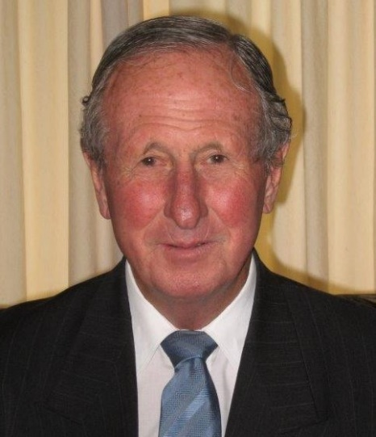
As Lindsay’s career evolved and experience broadened, he developed a passion for and became an advocate for what is now widely known as Day Surgery – as an effective alternative to lengthy and expensive service delivery in acute bed hospitals. His efforts in this initiative were recognised with awards presented by the Australian Association of Surgeons and Royal Australasian College of Surgeons in 1987 and 1991 respectively, and his broader advocacy led to him being elected President of the International Association of Ambulatory Surgery in 2001. He also developed a frustration with some failing reforms in undergraduate medical education from ca. 2000, and argued for; commencement focus on didactic teaching of the basic sciences, and especially anatomy, and; the development of day surgery centers in Teaching Hospitals to ensure student access through this new format of service delivery.

Outside of medicine, Lindsay was dedicated to his family, and for himself had keen interests in ocean racing, and agriculture – both of which sheet back to his early life – and in his later years, volunteering for restoration work on the pilot vessel John Oxley at the Sydney Maritime Museum Sea Heritage Dock in Pyrmont, NSW. After almost 10 years of peaceful retirement, he was impacted by a stroke in September 2017, and despite a gritty tenacity for life, peacefully succumbed to his ailments on 21 July 2021. He is survived by; his wife, Helen; their children, Rowan, Cathie, Anna and Lizi, 11 grandchildren, and; seven great-grandchildren – the majority of whom have simply known him as ‘Doc’. He will be very missed but his legacy lives on in all of them.

This obituary was provided by Mr Lindsay Roberts son, Rowan Roberts

