AGENDA ITEM 1.7
OBITUARY

DR WILLIAM “BILL” “WILLY” DOWNING WALKER
PLASTIC & RECONSTRUCTIVE SURGEON
14 May 1929 – 06 November 2022

A Man we can all be both happy and proud to remember.  Bill died just over a month ago. He died quietly at the age of 93. He had the opportunity to say farewell to his partner Angela Jones, his sons, Colin and David and a host of his grandchildren. Their words at his funeral celebrated the joy of their lives with him whilst their emotions portrayed their loss.  If you knew Bill, you understood.  Bill was indeed a remarkable individual. He was remarkable in what he did and so very individual in the ways he did it.  Bill was born in Randwick, N.S.W. His father was a bookmaker for whom he did the numbers from time to time and his mother was a Victorian Lady with high musical skills who led Bill into a musically happy life.  Bill was the youngest of eight children. He had an elder brother, Ted, who taught him to shoot a rifle, and six elder sisters. It was the depression and not an easy time. He spoke of tripe as the most affordable protein and said he remembers each of his toys because they had so few. | 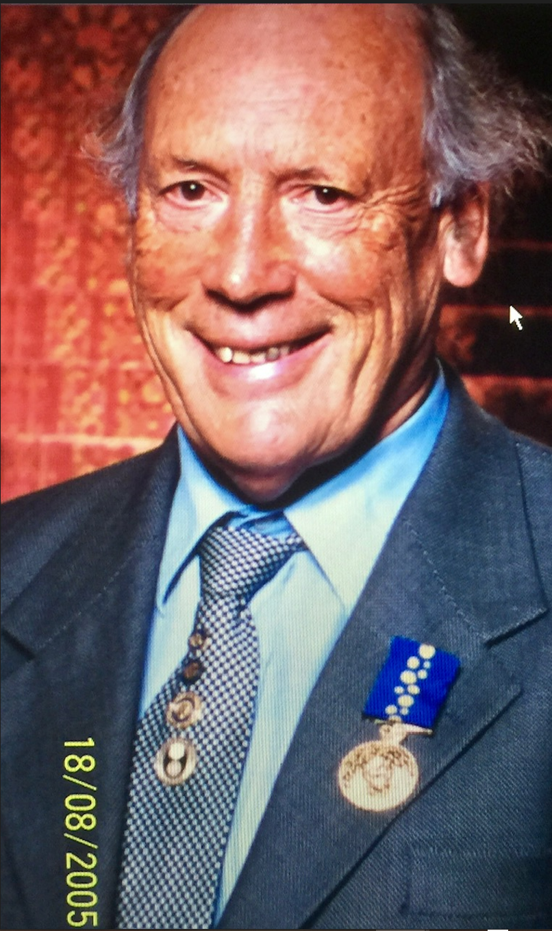

Before the War, the family moved to Katoomba, where Bill went to high school. Bill excelled at swimming, being recurrent school champion and setting a breaststroke record that stood for over 10 years. This was the start of a great career in swimming for Bill.

Bill was not a great student and actually sat the leaving certificate twice, failing English the first time. But the second go got Bill into Medicine at Sydney University, graduating in 1953. This was the start of a great career in medicine for him.

Bill elected to go to Newcastle as a junior medical officer and was stationed at Cessnock Hospital for his first year. This was where Bill began to define himself. Doris Hyams, a 20 year old nurse, saw Bill for the first time and said: "I'm going to marry you Dr. Walker!” Just 5 months later they married. Bill, in his first year out, was designated the anaestheist for the hospital. He gave over 1,000 anaesthestics. This exposed him to surgery and surgeons. He decided he could do it better and set out to do so.

Bill next went to Paramatta Hospital which he credits with giving him a very full experience in road trauma, paediatricS and obstetrics. Hand surgery by Tom Gibson intrigued him. It is when he first considered formal surgical training. So, it was off to Perth and Princess Margaret hospital for children. Here he met Harold MaComb and discovered cleft lip surgery. It is also where he and Doris had their first child Alison.

Bill decided at this point to earn some money so that he could finance a trip to the U.K. he took up a position as the superintendent at Tara in Western Queensland for one year, but stayed for three. Bill enjoyed Tara. It was in Tara that he and Doris added to their family, having Colin and David.

He was a full-on country doctor. He did it all. He delivered over 200 babies, treated a wide variety of trauma, looked after snake bites and shot feral pigs and kangaroos. In fact, he was a good shot and took up competitive shooting. Years later he went on to win the “Bisley Cup” in the U.K. with a score of, wait for it, 997/1000 (15 shots, 14 bullseyes, 1 inner) over 600 meters.

By then it was time to head to the U.K., so the family boarded the “Castle Elise” and sailed to Glascow. Bill worked at Hairmyers Hospital and sat the Glascow Primary Course, going on to gain his Fellowship of the Royal College of Surgeons, Edinburgh. During this time, he met Ian Jackson, who offered him a job at the Royal Glascow Infirmary for a year where he worked with Ian McGregor. In Glascow he did a lot of head and neck cancer and hand surgery. Then he was off to Manchester to work with Randall Champion. This he loved because of the workload of clefts and other congenital deformities.

But life dealt some blows to Bill and Doris in Scotland. Doris developed diabetes and unfortunately, they lost 3 babies, one stillborn and a pair of twins who died at birth in Manchester.

Serendipitously, he met Dr Sweeney, a plastic surgeon from Sydney at a hand surgery meeting, who told Bill there was a plastic surgery job going in Newcastle. Bill was interviewed on14 May 1968 and became Newcastle’s first ever “real” plastic surgeon.

So, Bill rolled up his sleeves and got stuck into one of the largest area health districts in New South Wales. He became the “full spectrum plastic surgeon”. Clefts, burns, breast deformities, breast reconstructions, hypospadias, hand trauma, hand deformities, head and neck cancer, compound injuries and redoes of the poor results of others were all part of his public workload. He set up the Cleft Palate Clinic and the Hand Surgery Unit. He chaperoned Peter O’Brien, Chris Howe and myself into practice in Newcastle. As head of plastics and a happy link between so many departments, he became intrinsically important to the provision of care in the region.

Bill worked in the public system and maintained a private practice in Newcastle from 1968 until 1994. During that time, he was the Director of Plastic Surgery for the Hunter Area Health Service. He also gained his Australian Fellowship in Plastic Surgery. He became a member of A.S.P.S. and was a foundation member of A.S.A.P.S. and was the Honorary Secretary from 1985 to 1988. He was the president of the N.S.W. Hand Club and a member of the Australian Hand Club. It goes without saying that he was a member of the Australian Cleft Lip and Palate Society.

So, is that all Bill did? Absolutely not!

Bill had an outstanding career as a Third World Plastic Surgeon. This period of work began in 1987 and went through until 2015, by which time Bill was 86 years old.

It began well before that, however, with a young girl named Margaret. Margaret from Northern Uganda. Margaret had been attacked by a hyena at age 7. In 1974, Rotary in Toronto N.S.W. arranged for Margaret to come to Australia for Bill to look after. Margaret underwent 20 operations by Bill. She stayed in Australia, became a nurse, and left her estate to Rotary Australia.

In 1985, Bill received a Paul Harris Fellowship, (a highly prestigious Rotary honor), for his work with Margaret. His ongoing work led to this award being upgraded to a Paul Harris Silver Bar in 1994. In 1996bbill received the Len Avard Award for his work in New Guinea and in2004, he received the Service Above Self Award from Rotary as well.

Bill became a Rotarian in 1991 and went on to become a president locally within Rotary. His surgical involvement with Rotary included work with Rotary Overseas Medical Aid for Children (this body had its genesis in a trip by Bill with Barry Cooper to Lambasa in 1988), Rotoplast to South America Dhaka and the Philippines and Alliance for Smiles in China, Bangladesh and Myanmar. Bill worked with Interplast, doing many trips, including Fiji and Kiribas, (Doris, Bill and I went to Lambasa together in 1987). He also did work with Overseas Surgical Service Australia to West Timor, the Philippine Australian Medical Association.

Bill became known worldwide within Plastic Surgery circles and, through various word-of-mouth contacts, did sundry trips to a wide variety of places. He would go to an international meeting and be asked if he could do a working trip to some far-away place to help out. He sadly reported that, when asked if he could go to Rwanda, to treat war victims he had to say that he simply did not have enough time. These trips were commonly self-funded.

OK. So, what did all this add up to and where did Bill go?

Bill, accompanied by his wife Doris when she was alive, made 41 trips to underprivileged countries, spread over 34 years.

The trips were to places all over the world including: Malawi, Mozambique during the Renamo revolution, Uganda during Idi Amin’s reign, Ghana, China and Peru, along with about 20 trips through the Pacific region.
There are so many stories about these trips, but a favorite of mine is told by his nurse for most of the trips, Lyn Thorpe. While walking back to the hotel in Maputo, Malawa, bill saw about 50 children sleeping on the ground outside a Catholic convent. They were the overflow from the 150 sleeping inside. The next day Bill bought 50 mattresses for them. Lyn says that Bill’ average operating day on tour generally consisted of five to seven mixed cleft cases. She also tells of a patient in Peru with a severe bilateral cleft whom the two American surgeons on the trip would not touch. Bill did the operation as a single procedure. His result is pictured in his book and is testimony his excellent skill.

Bill’s last trip was to Dhaka in 2015 at the age of 86. He said he was still in great health, but was happy to leave behind the twelve-hour operating days. By then, his passport must have been a very interesting document.

OK, so much for Bill’s Plastic Surgery career. What did he get up to in his spare time?

Doris was a Christian. Bill was an agnostic at best. That was until , at the age of 51, he too became Christian. He became a highly active Christadelphian and still attended and read at church into his 90’s. Ther is no doubt that Christianity was a driving force in his life and work.

Bill became very involved with Rotary. His initial involvement was via the support rotary gave, beginning with Margaret Ilukol and continuing throughout his aid-work career. He became directly involved by joining Rotary in 1991, remaining an active member until 2018. He was active as a representative for Rotarians Against Malaria for 11 years and Rotarian Oceana Medical Aid for Children for 6 years.

Anything else? Yes.

Swimming was a self-taught exercise he loved. Bill suffered from asthma/COAD and he said that swimming was his best defense against it. So, swim he did! He competed successfully at university, but began his really competitive swimming when he joined the Masters in 1999. He swam his first masters race and won it. He said he loved the adrenalin buzz of winning that race and got serious. He had his first swimming lesson at age 70. At that age he even learned butterfly. He went on to compete regularly in the FINA World Masters, the World Masters and the PAN-Pac Masters Games. His favorite meeting was in Kazan, Russia in 2015, when he won 5 gold medals out of 5 races. His last competition was in 2019 in Korea where he wo 4 Golds and a Silver. He loved it.

His granddaughter tells of attending an event and being asked who she was there to support. She replied: “My Granddad. He’s the one standing on the middle block in the speedos with “WILLY” written on the front of them.”

Bill played hockey too. He was a first grade player at Sydney University and continued for many years on return to Newcastle. He loved a round ball sport and played competitive golf, tennis and bowls. Add sailboarding to that and, according to Bill’s sons, you never got to rest on the weekend.

Anything else? Yes. The cello and flying.

As I said earlier, Bill’s mother was an accomplished pianist. They had 2 pianos at home. Bill loved it and would practice 2 hours a day and passed level 6 with credit whilst at school. Bill took up the cello when he came to Newcastle and went on to reach seventh grade. He played in local symphony orchestras for over thirty years and joined the Amateur Chamber Music Society of New South Wales.

Bill’s son David became a pilot, so, at the age of 65, Bill decided to learn to fly as well. He got his license and bought a Turbo Cessna 210. He and David flew it around Australia. He became so proficient that he participated in flying Rotarian trips in the USA, Canada and Alaska.

Bill was often prompted to write his story. Eventually, with the help of his nephew Bruce Walker, he did. The book is called “Hard Yards.” Despite the title, it is a lighthearted and happy book. It is worth a read.
So, Farewell Bill. For those who knew you, you were a wonderful man. You have contributed so much in so many ways that Whilst the world will miss you, You leave it a much better place.

AWARDS : ORDER OF AUSTRALIA 1999
ROTARY PAUL HARRIS FELLOW 1985
ROTARY PAUL HARRIS FELLOW 2009
ROTARY SERVICEABOVE SELF AWARD 2004
ROTARY LEN AVARD AWARD 2007

This Obituary was provided by Dr John Newton FRACS a colleague and friend of Dr Walker

