AGENDA ITEM 1.7
OBITUARY

PROFESSOR SIR PETER MORRIS
VASCULAR AND GENERAL SURGEON
17 APRIL 1934 - 29 OCTOBER 2022

Professor Sir Peter Morris was born in Horsham, Victoria, was appointed Nuffield Professor of Surgery in Oxford at 39 years of age and became a world leader in Renal transplantation, clinical immunology and tissue typing. He died on 29th October 2022 of metastatic bowel cancer, at home in Whitney at 88 years of age.  Peter Morris lost his father Stanley to a heart attack and his brother Stan, to a car accident when only a boy, and as his mother was injured, he was sent to board at Xavier College, Melbourne for his secondary education. At school, he befriended Brian Collopy (later surgeon) who spoke fondly at his memorial service of Peter as a lifelong friend. Peter started Engineering at University of Melbourne but moved to Medicine and was a student at St Vincent’s Hospital, Melbourne. Peter excelled at sport, representing Australia in baseball and University in cricket. Competitive tennis and cricket matches later became an annual event between the Oxford and Cambridge Departments of Surgery. Peter also became an accomplished golfer. | 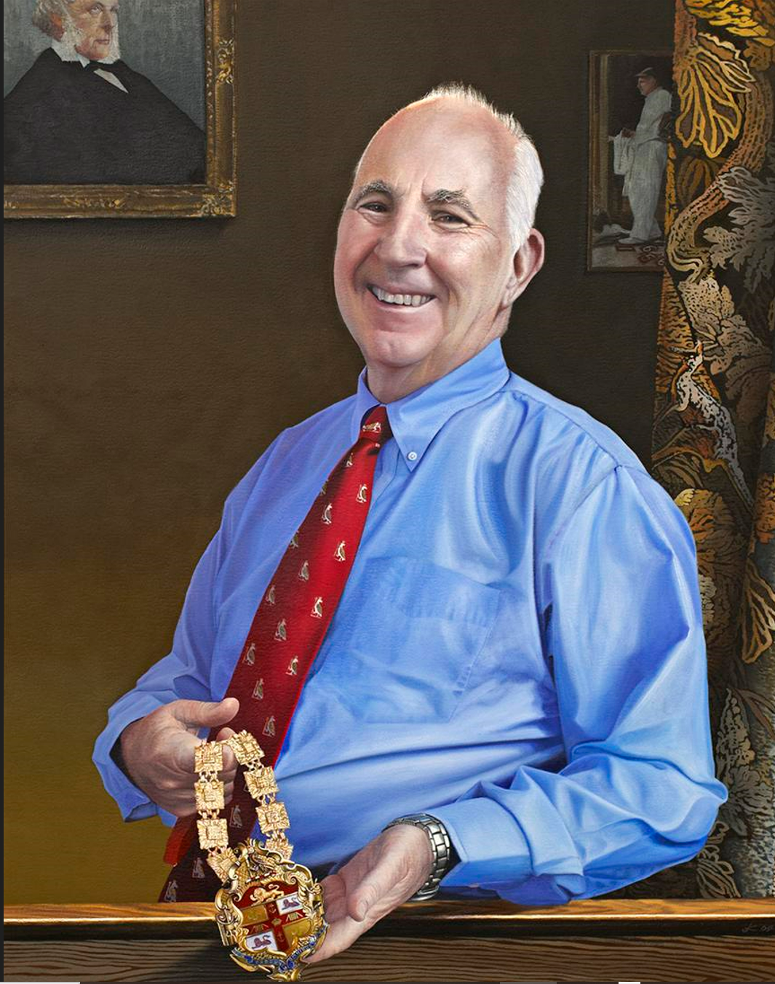
Peter Morris graduated in 1957, married Jocelyn, who became a respiratory physician, and began his surgical training in Melbourne. He and Joce then sailed to England, working and training at Southampton, and the Hammersmith, London, where the first living non related kidney transplant was performed. In 1964, he moved to the Massachusetts General Hospital, Boston as surgical resident and research fellow, with Professor Claude Welch. He then moved to Virginia to work with David Hume to set up a tissue typing laboratory with Paul Terasaki and together they defined the importance of humoral immunity and the risk of hyperacute rejection.

Peter and Joce returned to Melbourne in 1968. Peter was appointed as transplant surgeon at Royal Melbourne Hospital, to join Vernon Marshall who in 1963 had started renal transplantation with Professor Priscilla Kincaid-Smith, Nephrologist and Pathologist. Peter also set up and directed the tissue typing laboratory. There he worked with Alan Ting and John Fabre. He was appointed first assistant in the Department of Surgery at RMH and became Director of the Australian Kidney Foundation.

Peter Morris almost accepted the Chair of Surgery in Adelaide, but in 1973 he was offered the Nuffield Professor of Surgery at the University in Oxford which he accepted and commenced in 1974. In Oxford he started the Renal Transplant program with Dr Des Oliver, Former All Black, who was running a large home haemodialysis unit at the Churchill Hosptial, which then became the centre of transplantation. Peter had taken a number of his tissue typing lab staff with him to Oxford. The first two patients were transplanted on 29 and 30 January 1975 and both patients survived for many years with successful grafts, although one year graft and patient survival was only about 50% at that stage.
As a vascular and general surgeon, Peter also set up an academic department of Surgery at the John Radcliffe Hospital, performing lifesaving aortic and carotid surgery and some general surgery including splenectomy. Peter trained many surgeons in the art of vascular and transplant surgery, including many Australians and New Zealanders, who later took those skills back to their units.

Peter also established an internationally renowned research department in the Nuffield Dept of Surgery, in transplant immunology, tissue typing, cross matching, tolerance and more, the results of which improved transplant survival rates close to the excellent figures we now have. Numerous clinical trials were run from the NDS.

Many DPhil students worked with Peter and his colleagues and multiple publications, and book chapters eventuated. Peter Morris wrote the book ‘ Kidney Transplantation,’ now in its 7th edition and was founding editor of ‘The Oxford Textbook of Surgery’ plus editor to the journal ‘Transplantation’.

Peter Morris continued as Professor of Surgery and ran busy Renal Transplant and Vascular Surgical Units in Oxford until his retirement from the Nuffield Chair in 2001. This occasion was celebrated with a 3-day festschrift delivered by leading surgeons and scientists from around the world, plus a cricket match and banquet at Blenheim Palace.

Peter Morris was elected President of the Royal College of Surgeons of England in 2001 and worked in that role until 2004, visiting many surgical units to improve training and health delivery. He drove the implementation of the Research Fellowship Scheme, setup and ran a working party on Transplantation in the UK, helped establish a Clinical Effectiveness Unit to advance surgical audit, and then established the Centre for Evidence in Transplantation at the Royal College of Surgeons.

He later served as Chairman of the British Heart Foundation and President of the Medical Protection Society.

Peter was elected Fellow of the Royal Society in 1994, was awarded the Medawar Prize in 2006, the Lister Prize in 1997, knighted for services to medicine in 1996 and made Companion of the Order of Australia for services to medical sciences in 2004.

Peter was a great family man and is survived by Joce, his 5 children, Pete a paediatrician, Sarah a GP, Jim a software engineer, Liz a marine biologist and Michael a solicitor, eleven grandchildren and 3 great grandchildren.

Peter remained a proud Australian and was always friendly and approachable. He was an inspiring and encouraging person to work with and many of the transplant units in Australia and New Zealand are still staffed by surgeons (and some physicians) he trained and mentored. This included John Thompson, Richard Allen, Bob Jones, Arthur Richardson, Justin Roake, Jonathan Fawcett, John Preston, Howard Lau, Amanda Robertson, Al Saunder, Chris Russell, James Ferguson, Tony d”Apice, Jeremy Chapman, Ashley Irish, Peter Angus and Josette Eris.

And I was lucky enough to work as Peter’s transplant and Vascular Fellow and then as a Locum Consultant in Oxford from 1996-1998.

This Obituary was written by Dr Amanda Robertson FRACS, a colleague of Professor Sir Morris

