Guide to Donations and Deductible Gift Recipient (DGR)

Purpose and summary
The Royal Australasian College of Surgeons (ABN 29 004 167 766) (RACS) is a registered charity with the Australian Charities and Not-for-profits Commission and listed by name as a Deductible Gift Recipient (DGR) in the Income Tax Assessment Act 1997 (Cth).
Persons who make gifts or donations to DGRs such as RACS may in some circumstances claim those gifts as a tax-deduction.
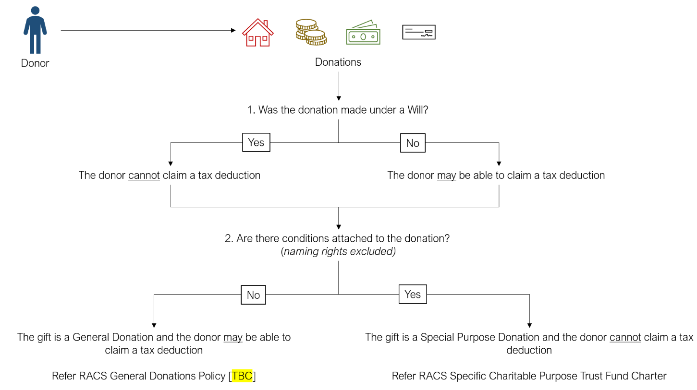
The purpose of this Guide is to enable RACS Foundation staff to determine when a donation is likely to be a tax-deductible gift, and whether it can be used by RACS for its general purposes. A summary of the key issue to consider (and their implications) is set out in the diagram below.

General donations and special purpose donations
Overview
RACS generally receives two forms of donations:
- a donation provided to RACS for its general purposes, or otherwise for no specific purpose (General Donation); and
- a donation that must be used for a specific purpose (Special Purpose Donation).

Determining whether a donation is General or Special Purpose
Determining whether a donation is a General Donation or a Special Purpose Donation can be a difficult exercise. Generally speaking, the best way of doing so is to consider the wording of the donation (for example, in the relevant deed of gift or Will).
A donation which has conditions expressed by words such as ‘must’, ‘shall’ or ‘I direct’ will likely restrict RACS’ discretion and mean that the donation is a Special Purpose Donation.
Example 1: Mr Andrew Lee dies and leaves $250,000 to RACS in his Will. The Will states that ‘I give $250,000 to the Royal Australasian College of Surgeons on condition that the College establish “the Andrew and Mary Lee Scholarship Fund”, to be awarded yearly. The scholarship shall be for medical research and the advancement of surgical techniques and treatments…’. The terms of the Will ensure that the funds are used to establish a specific scholarship for specific purposes. This donation is a Special Purpose Donation.

On the other hand, conditions expressed by words such as ‘may’ or ‘I request’ are less restrictive and the relevant donation is more likely to be a General Donation.
Example 2: Dr Joy McAfferty dies and in her Will leaves $50,000 to RACS. The Will states that ‘…notwithstanding the absolute nature of my gift and without imposing an obligation, I request that those funds be applied for the purpose of founding a research fellowship to be known as the Joy McAfferty Research Fellowship’ with no further conditions attached. The terms of the Will state that RACS does not have an obligation to apply the funds in a particular way, but include the donor’s request. This is a General Donation.

Donations with naming rights attached (as in Example 2 above) or which require RACS to report back to the donor/donor’s relatives at regular intervals can still be General Donations, as those ‘conditions’ do not restrict RACS’ ability to decide how the funds are used.
Conditions which limit RACS’ discretion (as in Example 1 above) will disqualify a donation from being a General Donation.
RACS Policies
All General Donations may be applied at RACS’ discretion, subject to [details or title of RACS donation policy/procedure] attached to this guide. All Special Purpose Donations are subject to the RACS Specific Charitable Purpose Trust Fund Charter (Charter) attached to this guide.
Due to the administrative costs involved with administering Special Purpose Donations, the RACS [preference/policy] is to only accept Special Purpose Donations with a value of AUD$[sum] or more.

When is a donation tax deductible?
Gift made during a donor’s lifetime
For a donation to RACS to be a tax-deductible gift, the following conditions must be met:
- the gift must be of money or property;
- the gift must be voluntarily given;
- the gift must be a General Donation (i.e. a donation not subject to conditions which would prevent RACS from determining how best to apply it); and
- the donor must make the gift without receiving, or expecting to receive, any material benefit or advantage in return.
The most common types of gifts (to the value of $2 or more) made to RACS that may be deductible include:
- money (cash);
- property (including trading stock) purchased during the 12 months before the gift was made;
- property valued by the Commissioner at more than $5,000;
- gifts of places listed in the Register of the National Estate (a list of natural, Indigenous and historical heritage places in Australia).
As noted in section 2 above, it is possible for a donation to have naming rights attached to it (e.g. the ‘Carly Ray Fund’) but still be a General Donation.
However, conditions which limit RACS’ discretion as to how best to apply the donation (e.g. must be used to support surgeons in rural NSW) will disqualify it from being a General Donation and being tax-deductible.
Example 3: Dr Emma Brown wants to donate to a charity. As a retired surgeon, Dr Brown would like to give back to her profession and decides to support RACS’ activities. Dr Brown donates $5,000 to RACS but does not specify what it should be used for. This donation is a General Donation, and it is likely tax deductible for Dr Brown.

Example 4: Mr Gary Williams sends RACS a cheque of $100,000 together with a document titled ‘Gifting Rules’. The Gifting Rules state that the donation is to establish a scholarship fund in his late wife’s name with the ability for Mr Williams to contribute additional sums from time to time. As the Gifting Rules do not specify what the donations must be used for, it is a General Donation and Mr Williams may be able to claim both the initial and subsequent payments as tax-deductible gifts.

Example 5: Mr Peter Lancaster wants to donate $300,000 to RACS to establish a program to support a fellowship scholarship. Mr Lancaster has sent a letter to RACS outlining that he would like the scholarship to only be granted to individuals from an indigenous background and would like to be involved in selection process. These limitations remove RACS discretion as to how the money is spent. The gift is therefore a Special Purpose Donation, and Mr Lancaster cannot claim a tax deduction on his donation to RACS.

Example 6: Mr Nicolas Winston wants to donate $150,000 to RACS to help establish a scholarship program and has expressed a desire for the scholarships to be targeted at supporting a disadvantaged minority groups (which fits with the charitable purposes of RACS), such as those individuals with an indigenous background. Mr Winston does not limit the use of the funds to any particular disadvantaged group and does not compel RACS to do so. The donation is therefore a General Donation and therefore tax deductible.

Gifts made where acknowledgement is given
A gift or donation may still be tax deductible even if there are ‘conditions’ which require or request the donor is acknowledged in some form. This might take the form of a plaque or naming rights to a scholarship or grant scheme.
Example 7: Ms Gleny Triffet wants to donated $200,000 to RACS to help set up a scholarship program. Ms Triffet would like the scholarship to be named the Henry Triffet scholarship program in her late husband’s honour. As a token for Ms Triffet’s donation, RACS creates a plaque to acknowledge the Triffet family’s generosity and the new building is named after Henry Triffet. This acknowledgement does not affect the general nature of the gift, and Ms Triffet would be able to claim a tax deduction on this donation.

Gifts made under a Will
A gift or donation made to RACS will only be tax deductible if the gift or donation is made during the donor’s lifetime. Donations made under a Will may be either General Donations or Special Purpose Donations, but are not tax deductible by the donor’s estate.
Example 8: Mr Robert Lopresti passes away leaving a Will which includes the following wording: “I give free of all duties or taxes the residue of my estate to ROYAL AUSTALASIAN COLLEGE OF SURGEONS ABN 29 004 167 766 for its general purposes.”. This gift is a General Donation but as Mr Lopresti’s gift to RACS is not made during his lifetime, his estate cannot claim a deduction on the gift.

Example 9: Under her Will Ms Margret Higginbottom leaves RACS $30,000. The terms of her Will state that: I give $30,000 to the Royal Australasian College of Surgeons. The College must use this money to establish a fund to support Aboriginal and Torres Strait Island medical students, the recipients of which will be selected by a selection committee based on the following criteria…’. This gift is a Special Purpose Donation but as it was not made during Ms Higginbottom’s lifetime, it is not tax deductible by her estate.

