AGENDA ITEM
OBITUARY

DR WARWICK RAYMOND HARPER FRACS
GENERAL SURGEON
14 FEBRUARY 1944 – 7 MAY 2022

Warwick joined me as a Visiting Plastic Surgeon at Manly District Hospital after his training in the UK. I was told in 1973 that Warwick was coming by his father-in-law, Dr Setright. When he arrived, you couldn’t miss him. He was so affable and easy to get on with. We shared the On-Call roster at Manly District, one week on and one week off.  Warwick was eager to learn as much as he could from his colleagues. That started at Hornsby Hospital as Registrar to William “Jim” Poate. Later, setting up his own private practice in Manly, Sydney Peninsular Plastic Surgery, he often sought advice as to the best method to treat a particular patient. He was always grateful for that advice, and his patients loved him. Warwick was then very generous, sharing his knowledge with younger colleagues, particularly how to set up a Day Surgery service. He cultivated far and wide friendships within our specialty. | 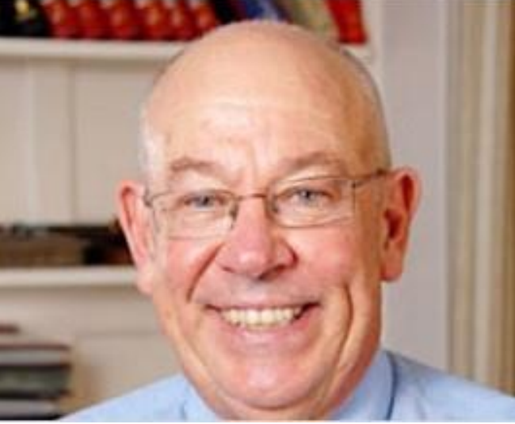

As a medical student at Sydney University, Warwick was a keen Rugby player and gained State representation. He played with Briars Rugby Club as part of the Invincibles who were the undefeated 1964 Kentwell Cup winners. That didn’t help his knees and later he suffered arthritis in other joints requiring prosthetic replacements. Despite this, he was always a very happy fellow.

Warwick commenced Veterinary Science before switching to Medicine and retained an interest in farm animals. Accordingly, he purchased a rural property in Nowra to house his stock. He was able to keep an eye on the them since he also ran a plastic surgery practice in Nowra. Warwick was a wonderful artist. He and I attended an art course with wide-ranging disciplines. We were tasked with creating our course partner’s head. This had to be constructed with clay, building up from the skull, then applying muscles, eyes and skin. We had to draw a nude on large paper while looking only at the subject. The self portrait was tricky, done on 4 large sheets of paper that were combined after completion of each quadrant. During this course, Bill Leak came and encouraged us to continue making art.

After retirement, Warwick did some wonderful water colours. Here is one of his self-portraits. He died 7 May 2022. | 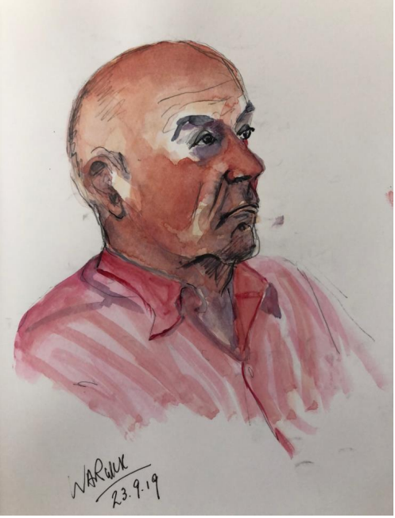

This obituary was written by Paul O’Keeffe, and obtained from the Australian Society of Plastic Surgeons website

