RACS Username

How to set up your account – User Guide

4 April 2022

Version 1.0

Steps to set up your account:
- Access the login / sign in screen for the desired RACS application / portal URL, for e.g., https://www.surgeons.org.

- On the login / sign in screen,
- Enter the new RACS username that you have received by email, in the ‘Email Address’ field as shown below.
Hint: If you haven’t received your new RACS Username, please search your inbox for an email with the subject line as ‘A new way to access RACS applications’. Your new username should read as ‘xx.yy@my.surgeons.org’.
- Click ‘Next’.
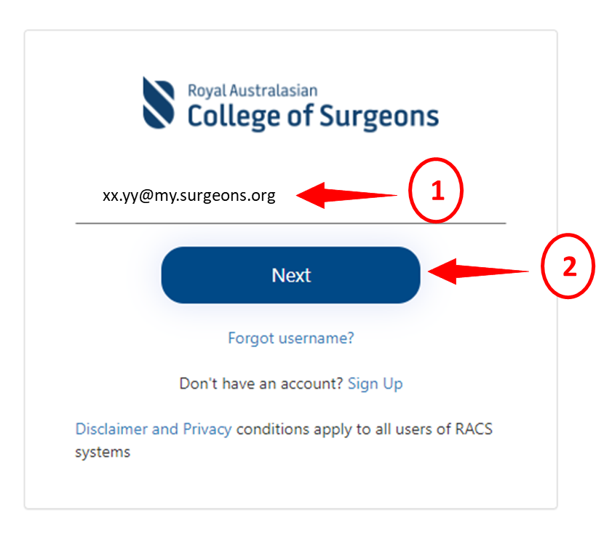
3) Enter the temporary password that you have received in the email and click ‘Sign In’.
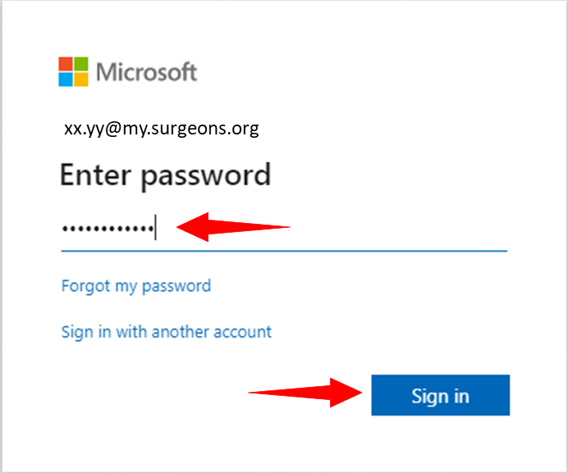
This will take you to the Microsoft More Information Required screen.
- On the Microsoft More information required screen, click ‘Next’ to set up a secure method to access your account.
Note: There are 2 methods of setting up a multi-factor authentication: via the Microsoft Authenticator App and your phone. Phone is the more preferred way. However, if you want to use the Microsoft Authenticator app, download it and follow the prompts to set it up.
If you to use the phone as your preferred option, continue below.
(This User Guide will cover securing the account via phone only.)

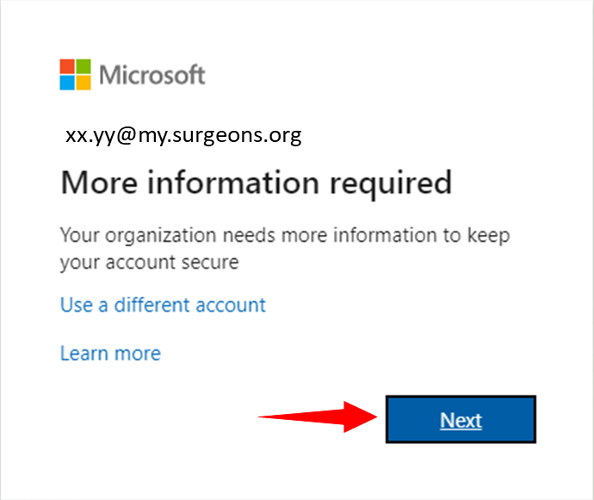

- The Microsoft Authenticator screen displays. Set up a method to secure your account by clicking ‘I want to set up a different method’ link.

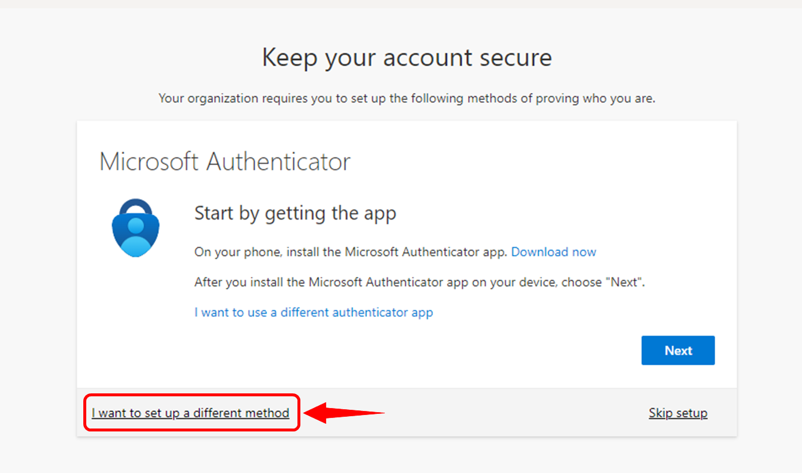

- From the Choose a different method screen, select ‘Phone’ in the dropdown list and click ‘Confirm’.
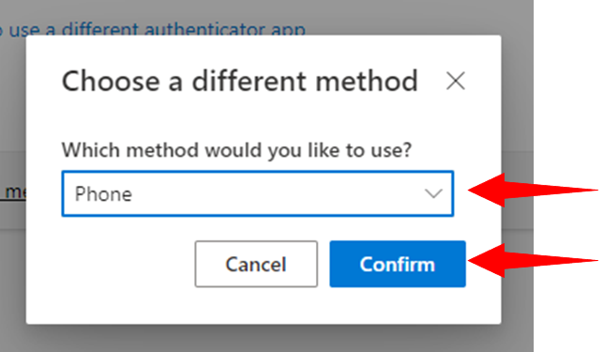

- From the Keep your account secure screen, proceed to set your phone number as your preferred method of authentication as below:
1. Select the country, for e.g., ‘Australia (+61)’.
2. Enter phone number.
3. Select the option ‘Text me a code’
4. Click ‘Next’
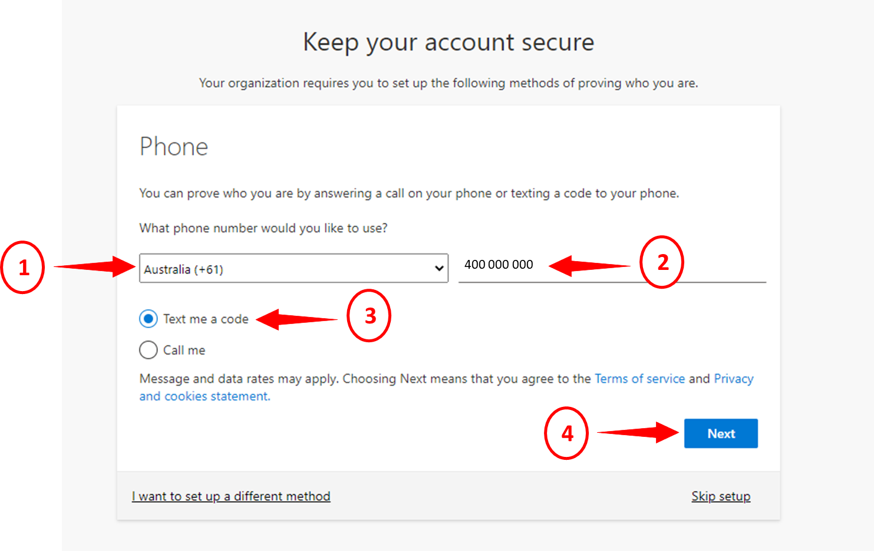
Note: The user can also select the ‘Call Me’ option. Just follow the system prompts to complete the set up.

- Complete setting up your phone as your preferred way of authentication as below:
- Enter the 6-digit code you’ve received on your mobile.
- Click ‘Next’.
If you do not get the code in the first attempt, click on the ‘Resend code’ link.
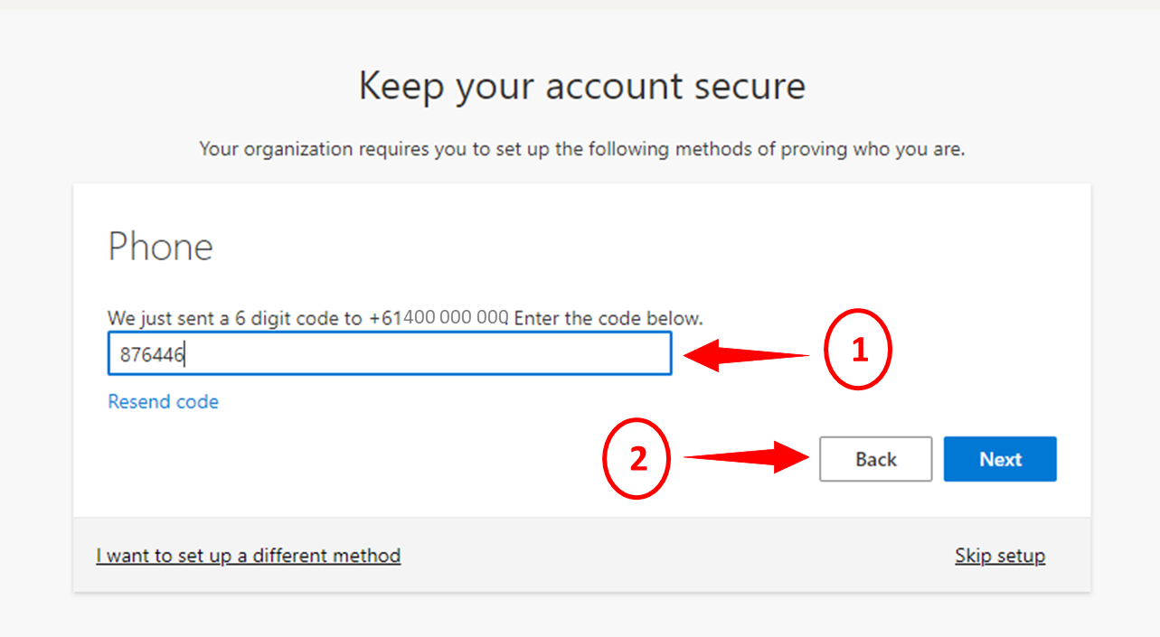
- Your phone number is now registered successfully. Click on ‘Next’ to proceed.
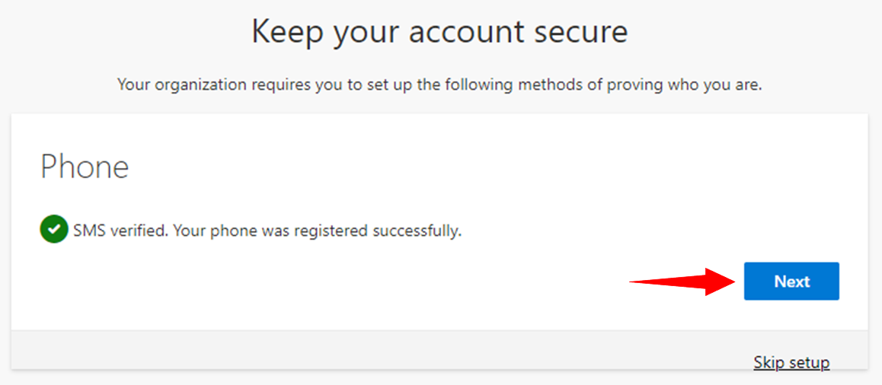
- You should see Success screen. The setup is now complete. Click ‘Done’.
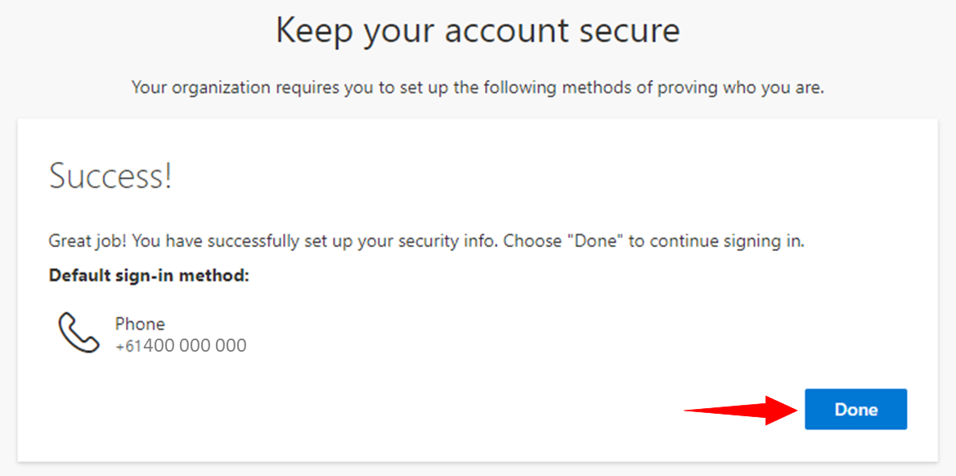
- The Microsoft Update your password screen displays.

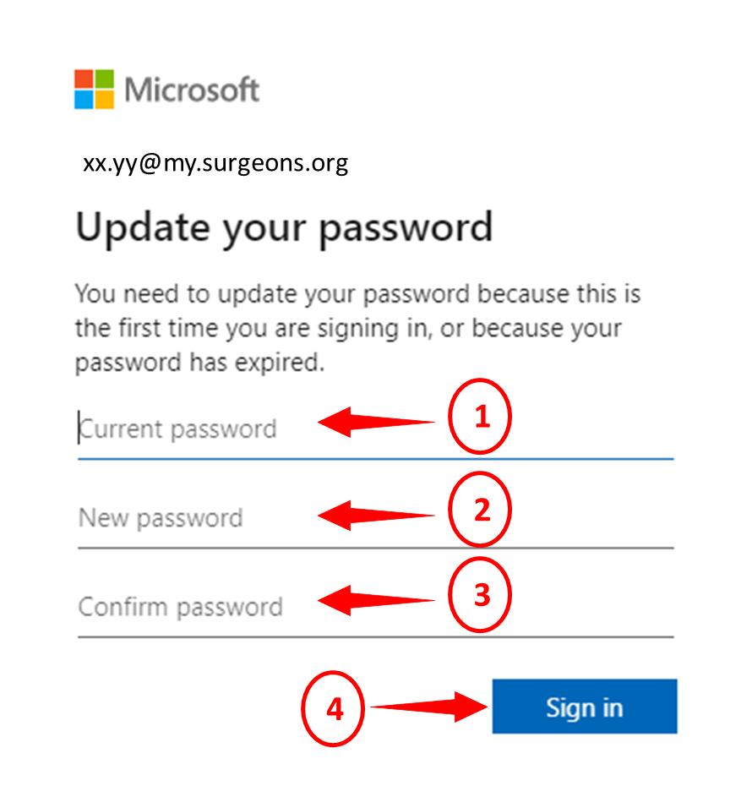
Enter the following:
1. Current Password - This should be your temporary password from the email.
2. New Password - Create a new strong password.
Note: Microsoft suggests the following password requirements:
- Passwords must be at least eight characters long.
- Passwords can have a maximum of 16 characters.
- Passwords can’t contain the user's account name or parts of the user's full name that exceed two consecutive characters.
- Passwords must contain characters from three of the following four categories:
- Uppercase letters (A through Z)
- Lowercase letters (a through z)
- Digits (0 – 9)
- Special characters @ # $ % ^ & * - _ ! + = [ ] { } | \ : ‘ , . ? / ` ~ “ ( ) ;
3. Confirm Password - Re-enter the new password.
4. Click ‘Sign in’.
You will be taken to the Microsoft Stay signed in? screen.

- On the Microsoft Stay signed in? screen:
- Tick the checkbox ‘Don’t show this again’.
- Click ‘Yes’
This will reduce the number of times you are asked to sign in.
Important: It is recommended you complete this step only if you use your personal device to log in to RACS online systems. Do not complete this step if you use shared devices, such as hospital computers, to access your RACS online systems.
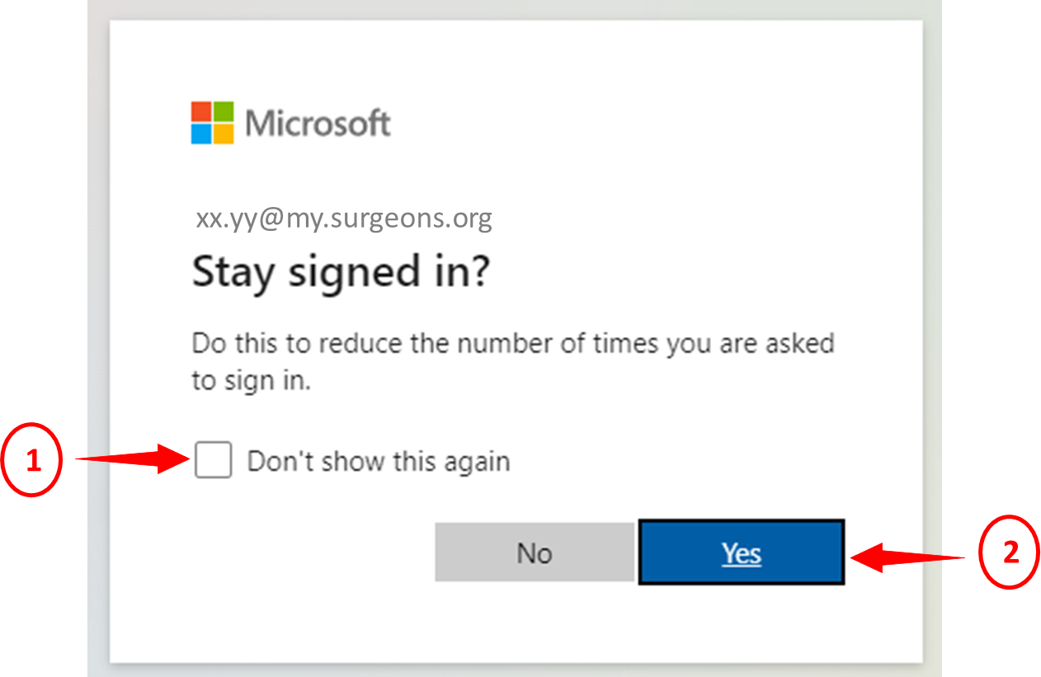
You will be logged into the RACS portal / application.
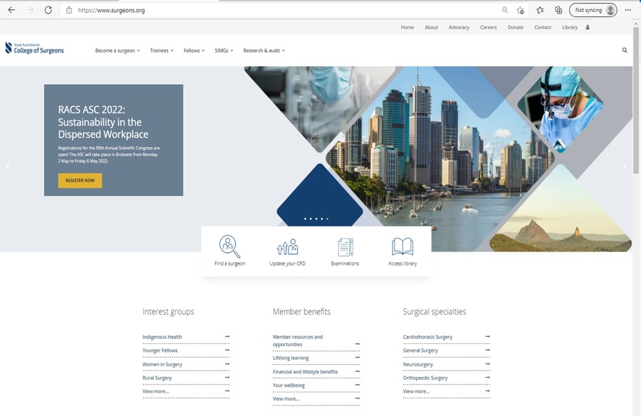
Important: Once you have set up your account with the new RACS username, you will no longer be able to use your non RACS email id (personal email id / email id you used previously) for accessing RACS portals / applications.
If you have any questions, please contact RACS Service Desk team on service.desk@surgeons.org.

