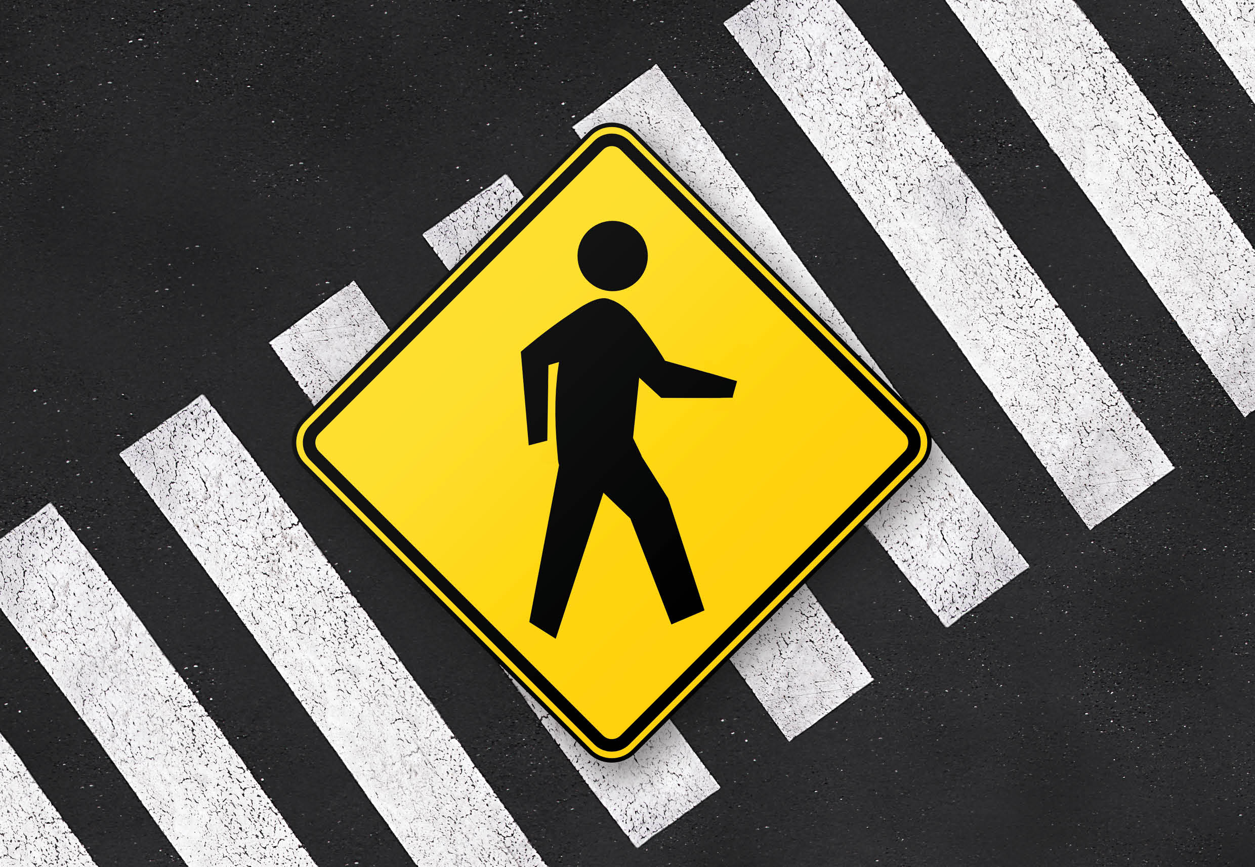

2019 Trauma Symposium
Program
Pedestrians – staying safe
Wednesday 13 November 2019
Hughes Room, RACS, 250 Spring Street, East Melbourne
Pedestrians – staying safe
Program Wednesday 13 November 2019
Session 1 Risk Factors/Scope of the Problem 0900 – 1030
Times | Topic | Presenter
0900 5 min | Opening | Dr John Crozier, Chair RACS Bi-National Trauma Committee
0905 10min | Welcome and Introduction | Dr Valerie Malka, Chair RACS Road Trauma Advisory Subcommittee
0915 15min | Pedestrian Case Presentation | Dr Mary Langcake, Trauma Surgeon
0930 15min | Distracted Walking | Dr Grant Christey, Director of Trauma, Waikato Hospital Hamilton
0945 15min | The Scooter Epidemic | Harold Scruby, CEO, Pedestrian Council of Australia
1000 15min | Intoxicated Pedestrians | Dr John Crozier, Chair RACS Bi-national Trauma Committee
1015 15min | Safe Speed Limits | Raphael Grzebieta, Vict’n Institute of Forensic Medicine, Monash University, Professor of Road Safety Transport & Road Safety (TARS)
1030 30min Morning Tea
Session 2 Keeping them safe/Prevention strategies 1100 – 1300
1100 15min | Pedestrian Public Health | Professor Rebecca Ivers, Injury Epidemiologist, The George Institute
1115 15min | Vehicle Design for Pedestrian Protection | David Logan, MUARC Senior Research Fellow
1130 15min | Law Enforcement | Ray Shuey, Pedestrian Advocate
1145 15min | Walkable Communities | Ben Rossiter
1200 15min | Road Safety Education and Schools | Eric Chalmers, Co-Vice-President, Australasian College of Road Safety
1215 15min | Pedestrian Friendly Road Design | Bruce Corben, Road Safety Consultant
1230 10 min | Towards Zero | TAC
1240 20min | Q and A with the Experts | Valerie Malka Chair
1300 60min Lunch
Session 3 Hard Talk/The Way Forward 1400 - 1530
1400 15min | Future City Designs | Jason Thompson, Melbourne School of Design
1415 15min | Re:act – a Road Safety Initiative | Jerome Carslake, Manager, National Road Safety Partnership Program
1430 15min | The Pedestrian Council of Australia | Harold Scruby, CEO, Pedestrian Council of Australia
1445 15 min | Smarter Planning for Pedestrians | Hafez Alavi, Director Safe System Strategy Infrastructure Road Solutions
1500 20min | Great Debate: Driverless cars will increase Pedestrian injuries and deaths  For: Scruby Against: Langcake
1520 10min | Close
1530 Afternoon Tea

